Monthly Billing blog / email for parents

School payments, sorted.
We are pleased to share some exciting news about the school’s online payment system, SCOPAY. To help you stay on top of paying for dinners, breakfast club, after-school club, school trips and events, you can now set up a Monthly Billing agreement, which takes care of these payments for you.

What is Monthly Billing?
Monthly Billing is the easiest way to regularly settle or top-up your accounts with the school.
It totals your outstanding balances, and any top-ups needed once a month and automatically processes the card payment on your chosen date.
You will receive an email with your balance details and the total to be charged, the day before the payment is processed, for peace of mind.
You can make changes to your agreement, including the payment date and card, at any time through the SCOPAY website.

How can I get started?
- Log into the SCOPAY website [link: https://www.scopay.com/login]
- Follow the prompt or click on the Monthly Billing tab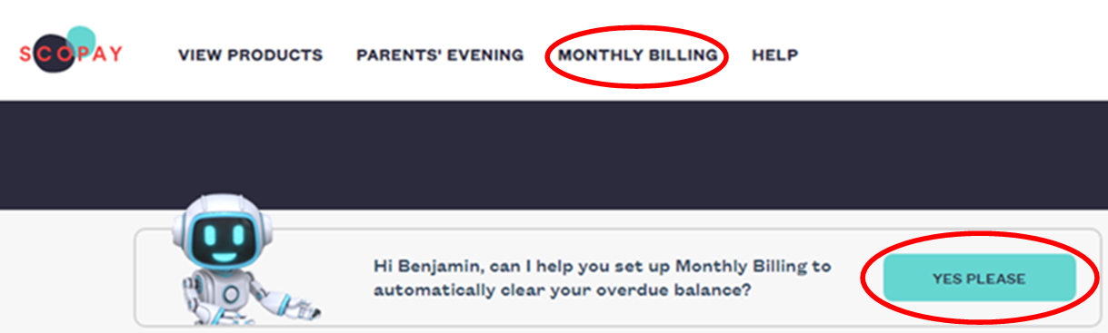

- Select the school, your preferred date and a saved payment card
- Choose whether you’d like to settle or top-up your balances for dinners, breakfast club and after-school club, and/or school trips and events. Then save your choices.
- Relax – SCOPAY will send you a summary by email and process your payment automatically each month.
[Delete as appropriate]

