Epson printer
TM- T20 and T20II
Installation Guide

Tucasi Ltd Wessex House Upper Market Street Eastleigh Hampshire SO50 9FD
School Support - 02380 016564 Sales Team - 02380 016563
www.tucasi.com
Copyright Tucasi Ltd 2004 - 2022

CONTENTS
1. About this document 2
2. Installing and configuring the printer 2
2.1. Installing the printer 2
2.2. Testing the receipt printer 8
2.3. Configuring the default settings 8
3. Troubleshooting 9
4. Support 9

- About this document
Thank you for purchasing the Epson receipt printer for use with Schools Cash Office. This document describes how to install the Epson TM-T20 and T20II receipt printer.
Check the label on your receipt printer to confirm the make and model prior to commencing the installation.
The Epson receipt printer can only be connected to one PC - it cannot be configured to be used as a networked printer with Schools Cash Office.
IMPORTANT: Do NOT plug in or turn on the power to the printer yet as this will trigger Windows to search for and install incorrect drivers.

- Install and configure the printer
IMPORTANT: Do NOT plug in or turn on the power to the printer yet as this will trigger Windows to search for and install incorrect drivers.
2.1 Install the printer
- Log on to Windows as a user with Administrator privileges.
- Go to the Epson download page:
https://download.epson-biz.com/modules/pos/index.php?page=single_soft&cid=4249&scat=38&pcat=3
- Scroll to the bottom of the page, read the online software licence agreement and tick Accept.
- Click on to download the Epson receipt printer drivers.
- Double click on the zipped ADK270ER19.exe file.
- Click on Run.
- Click on Unzip.

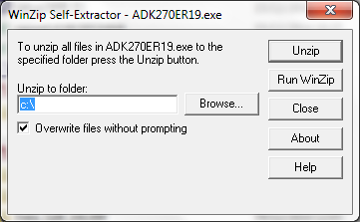 | 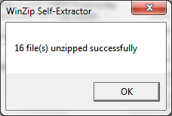
- Click on OK.
- Click on Close.

- Start My Computer and browse to the Local Disk (C:) drive.
- Double-click on OPOSADK.
- Double-click on ADK270ER19.
- Double-click on Disk1.
- Double click on the setup.exe.
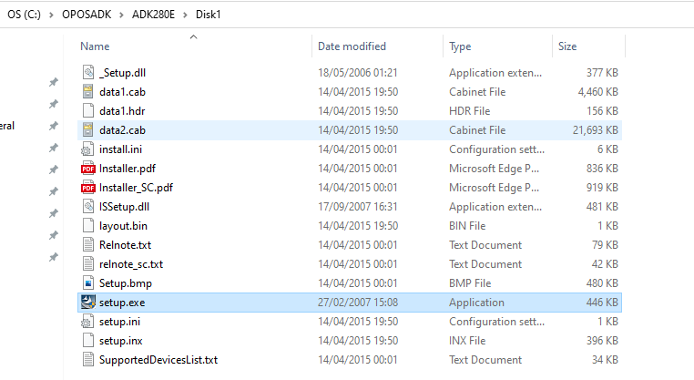
- Select the English language.
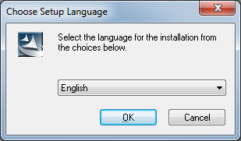
- Click OK.
- Click Next.

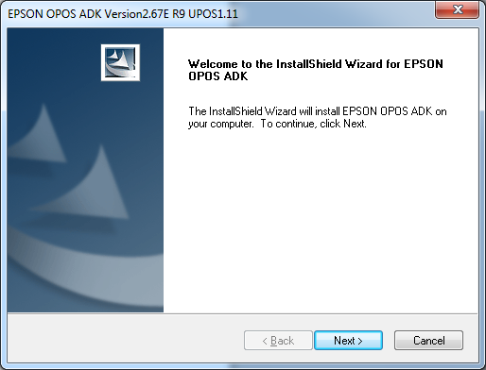
- Read the License Agreement and select I accept the terms of the license agreement.
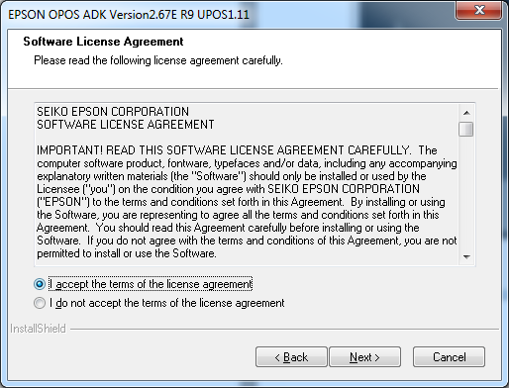
- Click on Next.
- Select No registry file.
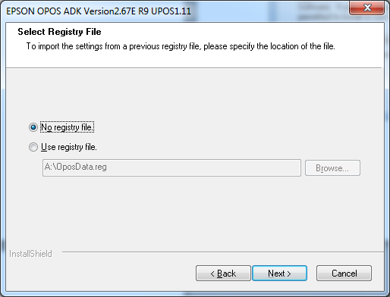
- Click on Next.
- Select Developer and click on Next.
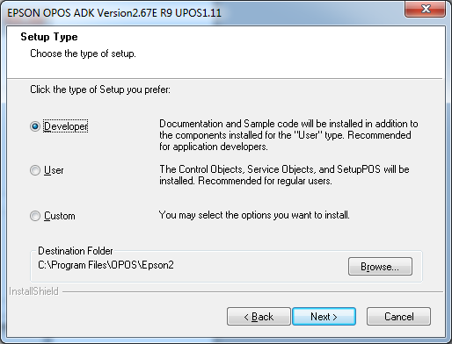
- Click on Next.
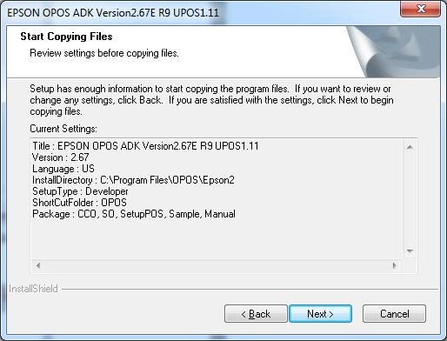
- Untick Serial port and tick USB port.
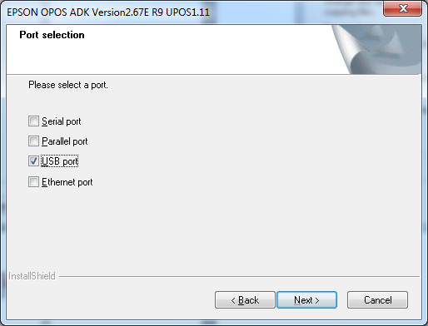
- Click on Next.
- Wait for the driver to install – the window may disappear at this point.
Wait for the next window to display.
- Untick Display the release notes.
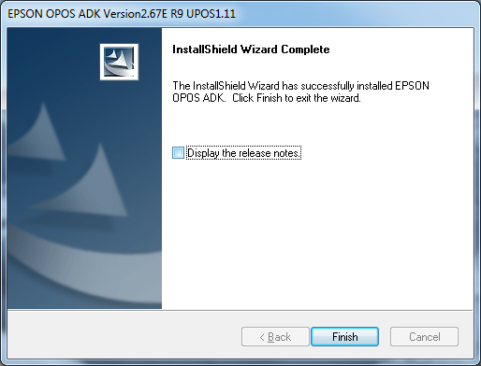
- Click on Finish.

- Connect the USB cable from the printer to your PC.
- Connect the power cable from the printer to the electrical supply.
- Insert the till roll.
- Switch the printer on.
- In the Epson control panel right-click on POS printer and choose Add New Device.
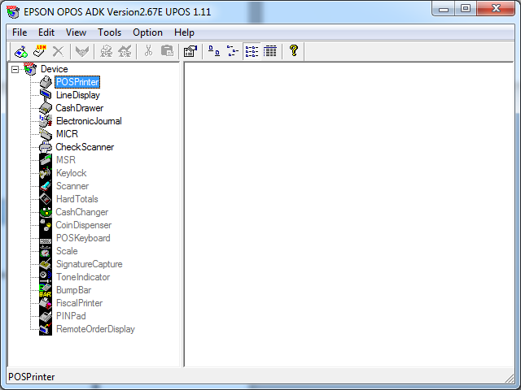

- Select the matching TM-T20 or TM-T20II under Select Device Name.
- Enter Receipt Printer as the LDN and ensure it matches the text below exactly
(i.e. capital R and P without any spaces).

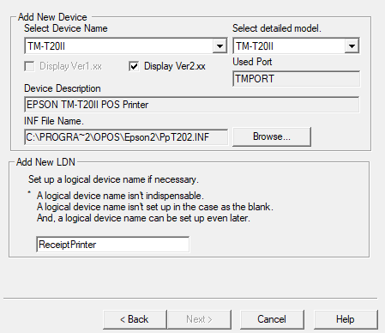
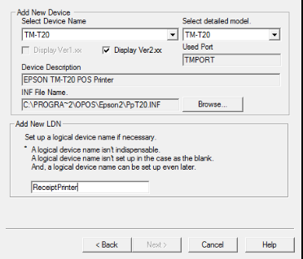

- Click on Next.

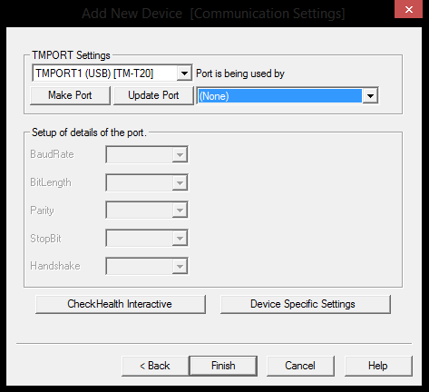
- Ensure the relevant TMPORT Settings are displayed to match your printer.
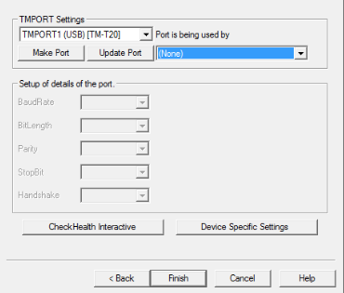
- Click on CheckHealth Interactive.
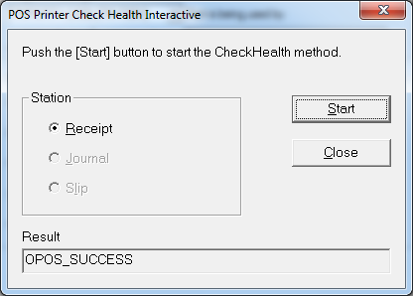
- Click on Start.

- The Result should display OPOS_SUCCESS if installed correctly.
- Click on Close.
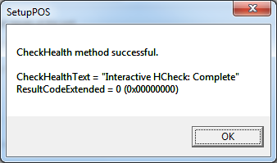

- Click on OK.
- Click on Finish.
- Close the Epson Control Panel and close the Browser window.

- Start Schools Cash Office and log on.
- On the Configuration tab, select System options.
- Click on the Device tab.
- Ensure the settings match those in the image displayed below.
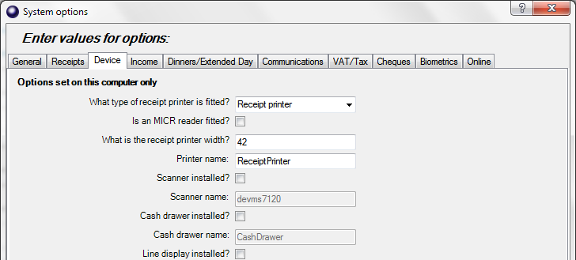
- Click on Done.

2.2 Test the receipt printer
If you are already using Schools Cash Office, test the receipt printer as follows:-
- Restart Schools Cash Office.
- On the Audit screen, select Income and expenditure log.
- Click on a transaction.
- Click on Print.
For new users, the receipt printer can be tested once the first transaction has been entered.

2.3 Configure the default settings
The settings displayed below can be configured on this PC.
- On the Configuration screen, select System options.
- Click on the Receipts tab.
- Troubleshooting
If the receipt printer does not print, refer to the FAQ on our website help.tucasi.com, click on the link to Frequently Asked Questions and select Receipt Printer FAQs - My Epson receipt printer isn’t working
(or go direct via this link https://tucasi.atlassian.net/wiki/spaces/SHC/pages/49021024/Our+Epson+Receipt+Printer+isn+t+Working?src=search).

Printing to an A4 printer (for PCs without a receipt printer installed)
In the absence of an Epson receipt printer, to set up Schools Cash Office to print to an A4 printer, refer to our website: on the Tucasi website help.tucasi.com, click on Getting Started with SCO, select System Options Settings SCO and select Print Receipts to an A4 Printer (or go direct via this link
https://tucasi.atlassian.net/wiki/spaces/SHC/pages/49020983/Print+Receipts+to+an+A4+Printer?src=search)

- Support
If you have any queries when installing the Epson receipt printer, please contact:
Tucasi Customer Support

02380 016 564

